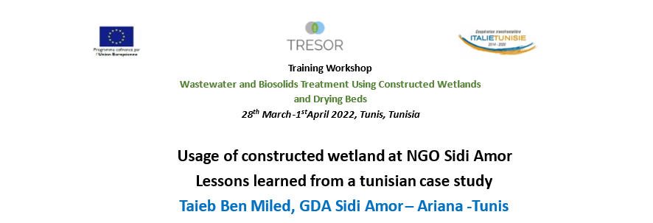
Le GDA Sidi Amor, partenaire associé au projet TRESOR https://lnkd.in/db5biG6Q , a participé activement à l’atelier de formation qui s’est déroulé en présentiel et à distance du 28 Mars au 1er Avril et dont ci-joint programme. Une composante « formation de terrain » s’est déroulée au GDA Sidi Amor. En partenariat avec plusieurs institutions scientifiques nationales et internationales et experts tels que ( Hamadi Kallali, Ahmed Ghrabi, Olfa Mahjoub, Tunisia, Andreas Angelakis, Greece, Jan Vymazal, Czech Republic, Jörg Felmeden, Germany, Fabio Masi, Italy, Pascal Molle, INRAE, France…)
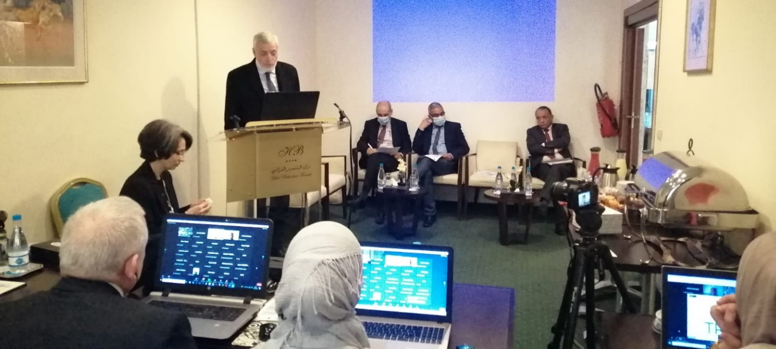
Ouverture officielle du Workshop et Introduction par Olfa Mahjoub) et MM.Ahmed Ghrabi, CERTE,Mondher Ben Salem, INRAT, Zouhaier Nasr, INRGREF etTaieb Ben Miled, GDA Sidi Amor

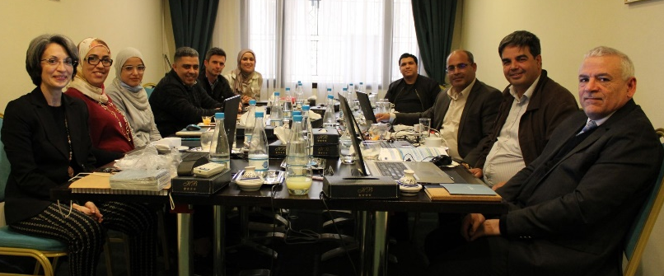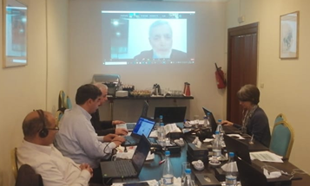

Formation de terrain au site du GDA Sidi Amor. Vendredi 1er Avril 2022
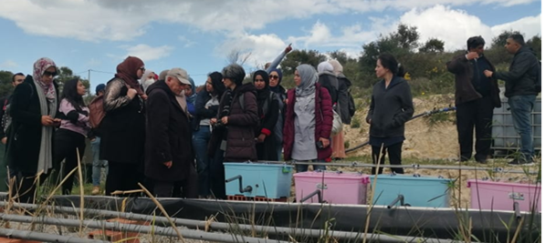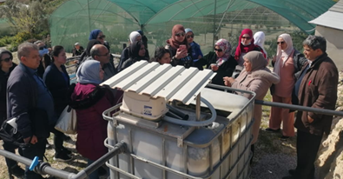
Explications par Hayet Cherif ( CERTE) du procédé de filtration et dessalement apporté par le Projet tuniso-allemand ( CERTE-FiW)installé au GDA Sidi Amor, en aval des lagunes plantes à macrophytes.
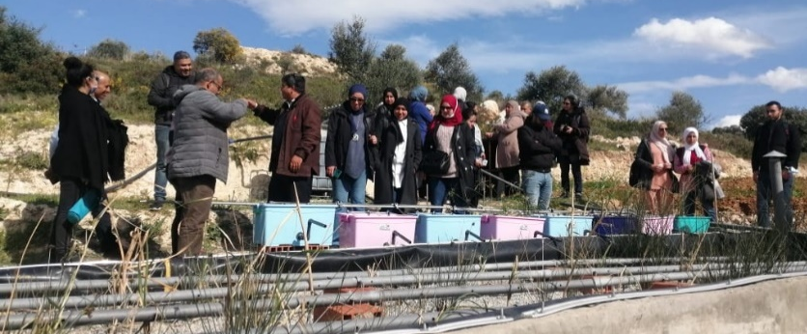

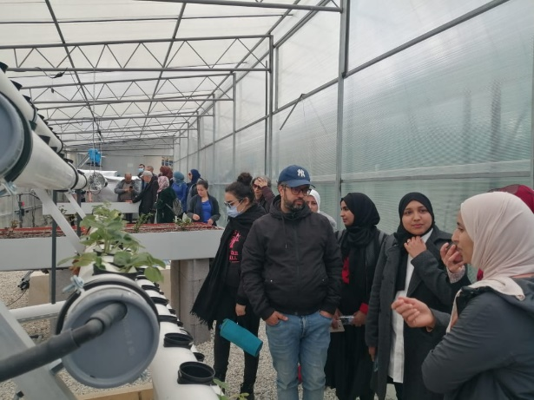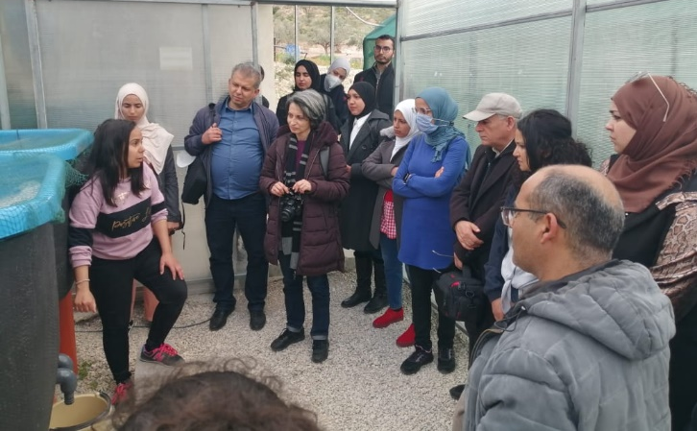
Visite de l’unité d’aquaponie utilisant les EUT post-filtrées. Expérimentations et innovations agronomiques diverses. Partenariat entre Terra Urbana (Germany)et Arts et Jardins ( Start up issue du GDA Sidi Amor) : entreprises spécialisées dans le paysagisme ( landscape architecture)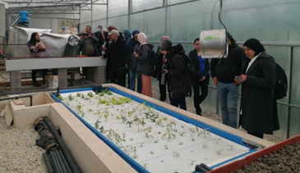
Training Workshop
Wastewater and Sewage sludge Treatment Using
Constructed Wetlands and Planted Sludge Drying Beds
28th March-1stApril 2022, Tunis, Tunisia
Programme
28 March 2022
Plenary Sessions (free access online)
Hotel Bélvèdere, Tunis
Session 1 : Opening session
Moderators: Olfa Mahjoub and Taieb Ben Miled
09:00 – 09:15 | Welcome Speeches  Zouhaier Nasr, INRGREF  Ahmed Ghrabi, CERTE  Mondher Ben Salem, INRAT  Taieb Ben Miled, GDA Sidi Amor  Fethi Ben Mimoun, Min planification  Salwa Chatti, Min planification  Faicel Sahraoui, Antenne STC
09:15 – 09:30 | Ice breaking session: getting to know each other’s
09:30 – 09:40 | Quizz (Mentimeter)
09:40 – 10:15 | TRESOR Project introduction, training unfolding, and housekeeping  Olfa Mahjoub, Tunisia
10:15 – 10:30 | Cyber break and networking
Session 2: Introduction to constructed wetlands
Moderators: Hamadi Kallali and Hatem Zgallai
10:30 – 11:30 | Wastewater management in small communities  Andreas Angelakis, Greece
11:30 – 12 :30 | Advantages and disadvantages of constructed Wetlands as compared to conventional treatment system  Jan Vymazal, Czech Republic
12:30 – 14:00 | Cyber break and networking
Session 3: Uses of Constructed wetlands
Moderators: Feliciana Licciardello and Zouhaier Rached
14:00 – 15:00 | Nature-based solutions for wastewater treatment and reuse: experiences in Italy  Giuseppe Cirelli, Italy
15:00 – 16:00 | Constructed wetlands and runoff management in Germany  Jörg Felmeden, Germany
16:00 – 17:00 | Constructed wetland for sanitation in rural areas in Tunisia  Hamadi Kallali, Tunisia
17:00 | Wrap up of the day
29 March 2022
Session 4 : Constructed wetlands for wastewater treatment: conventional approaches
Moderators: Thameur Chaibi and Mohamed Ali Wahab
Closed sessions (only by registration)
09:00 – 10:00 | Plants in constructed wetlands – function and selection  Jan Vymazal, Czech Republic
10 :00 – 11 :00 | Constructed wetlands in hot and arid countries: emphasis on the socio-environmental settings  Sarah Dan Haring, Kenya
11:00 – 12:30 | Cyber break and networking
Session 5 : Subsurface constructed wetlands use for wastewater treatment: novel variants and innovations
Moderators: Abdellaziz Zairi and Giuseppe Cirelli
12:30 – 13:30 | New types of constructed wetlands: concept and types  Fabio Masi, Italy
13:30 – 14:30 | Combination of CWs with other treatment systems: case of the APOC system  Kostantinos Plakas, Greece
14:30 – 15:30 | Usage of constructed wetland at NGO Sidi Amor: lessons learned from a Tunisian case study  Taieb Ben Miled, Tunisia
15:30 | Wrap up of the day
30 March 2022
Session 6: I design my constructed wetland for the wastewater treatment
Moderators: Giuseppe Cirelli and Hamadi Kallali
Closed sessions (only by registration)
09:00 – 10:00 | Constructed wetlands for wastewater treatment: from theory to practice  Pascal Molle, France
10:00 – 11:00 | Modelling wetlands using the HYDRUS Wetland model  Günter Langergraber, Austria
11:00 – 12:00 | Sizing and performance of constructed wetlands: applied example  Fabio Masi, Italy
12:00 – 13:00 | Cyber break and networking
Session 7: I design my planted filters for wastewater treatment
Moderators: Fabio Masi and Konstantinos Plakas
13:00 – 14:00 | Working groups session
14:00 – 15:00 | Presentation of the results
15:00 – 15:30 | Cyber break and networking
15:30-16:30 | Connecting TRESOR and on-going projects and open discussion (30 min)
16:30 | Wrap up of the day
31 March 2022
Session 8 : Introduction to planted sludge drying beds
Moderators: Hamadi Kallali and Olfa Mahjoub
Closed sessions (only by registration)
09:00 – 10:00 | Planted sludge drying beds: Concept, design, and operation  Pascal Molle, INRAE, France
10:00 – 11:00 | Sizing and performance of drying beds for sludge: from theory to practice  Fabio Masi, Italy
11:00 – 12:00 | Working groups session
12:00 – 13:30 | Cyber break and networking
Session 9: I design my drying beds for sludge
Moderators: Fabio Masi and Pascal Molle
13:30 – 14:30 | Presentation of the results
14:30 – 15:00 | Closing Quizz (Mentimeter)
15:00 – 15:30 | Wrap up and instructions for the field visit
1st
April 2022
Field Trip
08:00 Departure from INRGREF to Bent Saidane and Jougar
09:30-12:00 Guided tour on constructed wetland
12:00 Back to Tunis
13:30-15:00 Visit of the constructed wetland of GDA Sidi Amor
16:00 Back to Tunis

